12269 functional test instructions

- Assemble 11493 4-port boards and the 12269 SIU.
- Connect the 12269 with USB-C cable to the computer
- There are 4 “SIUs” on one 12269 board, each column of sensor ports corresponds to one SIU.
- We shall check one SIU at a time.
- Connect sensor devices to the ports that you want to test. (Use 12224 dual mag devices)
  - These sensor devices must be functional.
  - One easy way to check this is to see if they work with Ommo Service.
- Connect a 3.5mm aux cable to the 12269 board and connect the other end to a base-station powered through a breakout board. (This is for wired sync)
- Make sure the base-station is powered.
- Open CNC Test App
- Open the 12269 SIU com port
- First check if you see close to ~1000 PPS
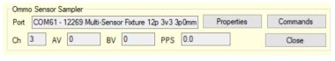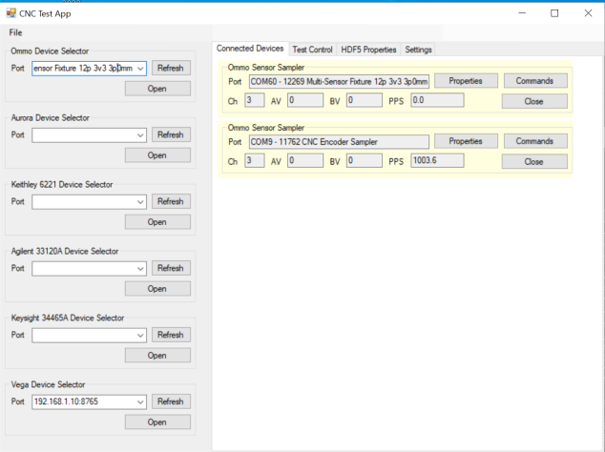

- Next, click “Commands”

- Click “Disable Data Mode”
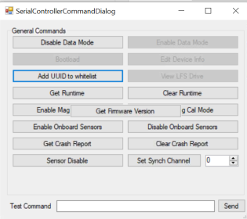

- Click “Edit Device Info”
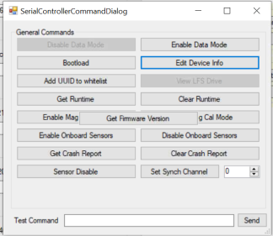

- Make sure you see the tabs for as many ports as you have sensor devices plugged in. e.g. Here we see 2 tabs and have 2 sensors plugged in.
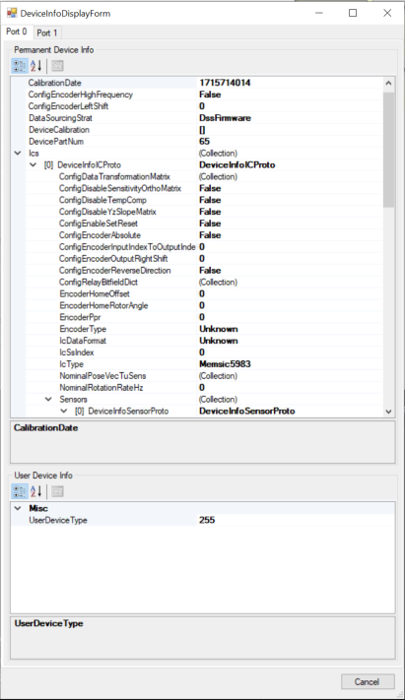

- Next, close this window, and click “Enable Data Mode”

- Close the Commands window
- Go to the Test Control Tab
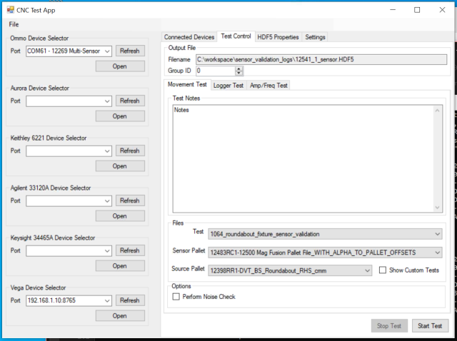

- Click on “Logger Test”
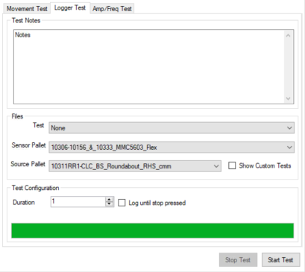

- Set the duration to 1 second.
- Click “Start Test”
- Open the resultant HDF5 file.
- Navigate to the sensor level for each device in the 12269 data group.
- We want to check if the data is present for all ICs for all devices which are physically connected to the SIU.
- To check if the data is present, navigate to the Sensor_0 level for each IC on each device. (You can use the HDFView software for navigating HDF5 files)
- For example, if we have two 12224 devices connected, we will have 4 ICs, and therefore, 4 sensors. Make sure you see data for 4 sensors in such a case.
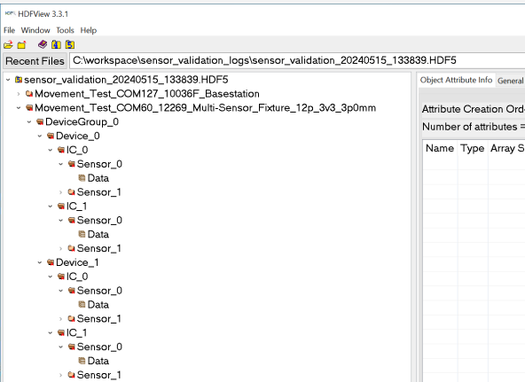

2 Devices, 4 ICs, 4 sensors
- If you have more or less 12224 devices connected, the IC and sensor number will change accordingly.
- If all above checks are successful, we can say that the ports which have sensor devices connected to them are functional. We need to repeat the above steps and check all 48 ports on the 12269 board.

